Project Design Phase-I - Solution Fit

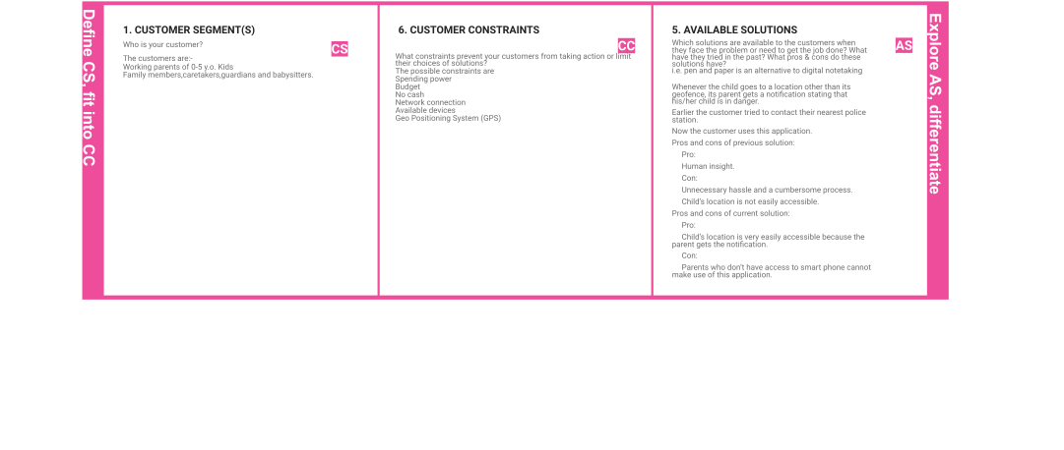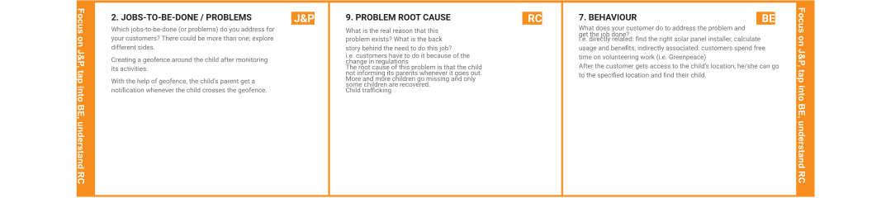

**Project Title:** IoT Based Safety Gadget for Child Safety Monitoring & Notification

**Team ID:** IBM-Project-PNT2022TMID43472

**TEAM MEMBERS:** M.Nivetha, M.Rihnika,D.Prem, K.Samyuktha prithyankara

|  |  |  |  |  |
| --- | --- | --- | --- | --- |
|  | **3. TRIGGERS TR**  What triggers customers to act? i.e. seeing their neighbour installing solar panels, reading about a more efﬁcient solution in the news.  Whenever the child crosses its geofence, the parent gets the notiﬁcation and acts accordingly. | **10. YOUR SOLUTION SL**  If you are working on an existing business, write down your current solution ﬁrst, ﬁll in the canvas, and check how much it ﬁts reality.  The customers are the parents, guardians, caretakers and babysitters.  We constantly monitor the child’s movements and create a geofence for the child. Whenever the child crosses the geofence(i.e. the child goes to another location other than its usual ones) the parent gets a notiﬁcation stating that his/her child has crossed the geofence, so that the parent gets alerted. | 1. **CHANNELS of BEHAVIOUR CH**    1. **ONLINE**   What kind of actions do customers take online?  The customer constantly monitors his/her child and gets access to their location. The customer gets a notiﬁcation when something suspicious activity occurs.   * 1. **OFFLINE**   What kind of actions do customers take ofﬂine?  After tracking the child’s activity, the customer goes to the speciﬁed location whenever the child crosses the geofence. |  |
| **4. EMOTIONS: BEFORE / AFTER EM**  How do customers feel when they face a problem or a job and afterwards?  i.e. lost, insecure > conﬁdent, in control - use it in your communication strategy & design. Whenever the customer faces the problem, they tend to feel anxious, upset and worried, frightened.  After they get to know that their child has crossed the geofence , the parent identiﬁes the child’s location using this application and feel relieved. |